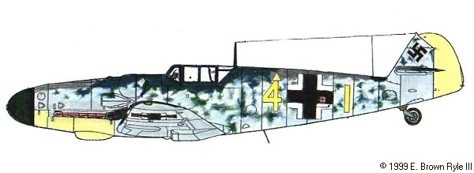

JG 26 A Special/Optional Rule

JG 26 was a German fighter unit of some reputation which was stationed in the Netherlands and in Northern France during the historic context of the game. As the 8th Air Force Bomber Command encounters with the Luftwaffe grew more intense the legend of the yellow nosed ME 109s began to emerge. They were referred to as “The Abbeville Kids” We reflect the legend and the high skill level of this famous unit with this special rule.

JG 26 is a threat to any B17 formation because there is a higher than normal chance of encountering skilled fliers in greater numbers, especially expert and ace skilled pilots.
Pilots from JG 26 are highly motivated and are known to press home their attacks with more intensity than the average fighter unit.

The JG 26 optional rule is implemented as follows:
.
Encounters with JG 26 occur in a limited geographic area. JG 26 will be encountered only on missions to Abbeville, Amiens, Antwerp, Lille, Meaulte, Paris, Romilly-Sur-Seine and St. Omer. (If later rule modifications allow they may also be encountered in Zone 3 on deeper penetrations into northern and central Germany where the GAZ is /F; /B; /H or /G)

Any time there is a wave encounter with multiple ME-109’s (and no other aircraft type) there is a 50% chance that the attackers will be JG 26. These wave numbers from Chart B3 are 12,14,24,33,42,54,65.

When JG 26 appears any extra ME-109s that are encountered due to B17 formation position will also be JG 26 fighters.

All fighter cover rolls against JG 26 are read in the poor column.

JG 26 ENCOUNTER AND SKILL ALLOCATION CHART

1d6 | JG 26 |  | 2D6+ | MAX PER
Encounter Roll | Skill Level | %TO SELECT | % EQUIVALENT | WAVE | EXTRAS
 | EXPERT | 17% | 2,3,4 | 2 | Read extras to lower level
1-3= JG 26 | ACE | 22% | 5&10 | 3 | Read extras to lower level
4-6= Normal | VETERAN | 61% | 6-9,11,12 | 5 | Read extras to higher level
 | GREEN | 00% | xx-xx | 0 | (None Encountered)

JG 26 A Special/Optional Rule

JG26 Expert Pilot Performance

Treat as a M6 Chart Ace plus
Experts always make successive attacks even after a miss plus
Ignore FCA minus 1 result (the hits do count for multiple hit affects) and
Add 1 hit to all Expert hit totals.

If JG 26 is not encountered proceed through the combat steps in the normal fashion.

If JG 26 is encountered follow the B17 Combat Steps with the following modifications:

B17 /JG 26 COMBAT STEPS

1) Enter map zone.

2) Determine # fighter waves (Charts B1 or B2 and zone gazetteer).

3) Determine # fighters each wave (Chart B3 and formation position add ons).

3.1) When Chart #B3 indicates wave #’s 12,14,24,33,42,54,65 roll for JG 26 appearance on the JG 26 Encounter Chart above.

3.2) If roll is Normal then proceed through the standard combat steps to resolve the fighter attack.

3.3) If roll is JG 26 then proceed to Step 4 below.

4) Apply fighter cover. Use the Poor Fighter Cover Column versus JG 26.

5) Create German pilots using JG 26 Skill Allocation Chart above.

6) Resolve JG 26 Fighter Attacks

6.1) Allocate B17 defensive fire.

6.2) Assign German pilots to attacking fighters using allocation
chart.

6.3) Resolve B17 defensive fire.

6.4) Roll fighters to hit.

6.5) Resolve B17 damage.

6.6) Determine & resolve successive fighter attacks.

